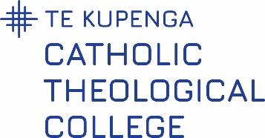

CTC Internal Moderator’s Report

Course:
Lecturer:
Assessment:
Site/Mode:
Course Date:

Moderator’s Analysis of the Assessment Grading | Yes or No
Grading judgements were consistent with the evidence
Grading judgements were consistent with assessment criteria
Grading judgements were consistent within/between grade levels

Comments: (if no, please comment - these can be general, or recommended changes or improvements)

Moderator’s Analysis of the Assessment Tool | Yes or No
The assessment was valid - good constructive alignment to the learning outcomes
The assessment was fair - obvious connection to course material
The assessment task was clear to students – clear instructions and expectations

Comments: (if no, please comment - these can be general, or recommended changes or improvements)

Moderator: …………………………………………………………………… Date: …………………………...

